CS 499 Module One Assignment Template

Complete this template by replacing the bracketed text with the relevant information.

- Self-Introduction: Address all of the following questions to introduce yourself.

  - How long have you been in the Computer Science program?
I have been working towards my Bachelor’s in computer science since 2017, so for about 10 years. I started at Northern Essex Community College, and moved to SNHU in 2024. I have been in SNHU’s computer science program ever since, a little over 2 years.

  - What have you learned while in the program? List three of the most important concepts or skills you have learned.
I have learned a lot since I started college. I had very limited experience with programming when I first begun and have learned so many different skills associated with it. The three most important concepts I have learned are:
Programming and Problem Solving: I have learned how to design, write, debug, and test programs while developing a structured approach to solving complex problems
Data Structures and Algorithms: I have gained an understanding of how different data structures and algorithms affect the efficiency and performance of software
Software Development Practices: I have learned how to design, document, test, and maintain software

  - Discuss the specific skills you aim to demonstrate through your enhancements to reach each of the course outcomes.
For my computer science capstone, I aim to demonstrate skills that showcase improvements in functionality, adherence to best practices and guidelines, and software design principles.

  - How do the specific skills you will demonstrate align with your career plans related to your degree?
Despite graduation being close by, I am still trying to figure out my exact career plans and aspirations. By showcasing my programming abilities and problem solving skills, especially focusing on the above skills, I can demonstrate that I am prepared to contribute to real world software development projects, regardless of where I end up in the future.

  - How does this contribute to the specialization you are targeting for your career?
Although I have not decided on a specific career path in software development yet, the skills I will demonstrate throughout this capstone will show a strong foundation in the field. These skills are valuable in almost every software development job, helping me prepare for the various career opportunities ahead of me.

- ePortfolio Set Up:

  - Submit a screen capture of your ePortfolio GitHub Pages home page that clearly shows your URL.
    - You already have a repository in GitHub where you uploaded projects in previous courses. Your ePortfolio will reside in GitHub but can link to work at other sites, such as Bitbucket.

  - Use the GitHub Pages link in the Resource section for directions on:
    - How to create your GitHub website and publish code to GitHub Pages
    - Issues, such as adding links to other sites

  - Paste a screenshot of your GitHub Pages home page with your URL clearly showing in the space below.



- Enhancement Plan:

  - Category One: Software Engineering and Design
    - Select an artifact that is aligned with the software engineering and design category and explain its origin. Submit a file containing the code for the artifact you choose with your enhancement plan.

IT 145 Project II

Note: Your artifact may be work from the following courses:

- IT 145: Foundation in Application Development
- CS 250: Software Development Lifecycle
- CS 260: Data Structures and Algorithms
- IT 315: Object Oriented Analysis and Design
- CS 320: Software Testing, Automation, and Quality Assurance
- CS 330: Computational Graphics and Visualization
- CS 340: Advanced Programming Concepts
- CS 350: Emerging Systems Architectures and Technologies
- CS 360: Mobile Architecture and Programming
- IT 365: Operating Environments
- IT 380: Cybersecurity and Information Assurance
- CS 405: Secure Coding
- CS 410: Reverse Software engineering
- IT 340: Network and Telecommunication Management
- IT 380: Cybersecurity and Information Assurance

    - Describe a practical, well-illustrated plan for enhancement in alignment with the category, including a pseudocode or flowchart that illustrates the planned enhancement.

IT 145 Project II is a program that runs a menu for a rescue animal service. I would like to improve this project by improving the class design by separating the UI from the business logic, currently all within the Driver class. I would also like to add proper data validation instead of just trusting what the user inputs, and error handling, something the program doesn’t currently have.

Planned Enhancement Class Diagram:
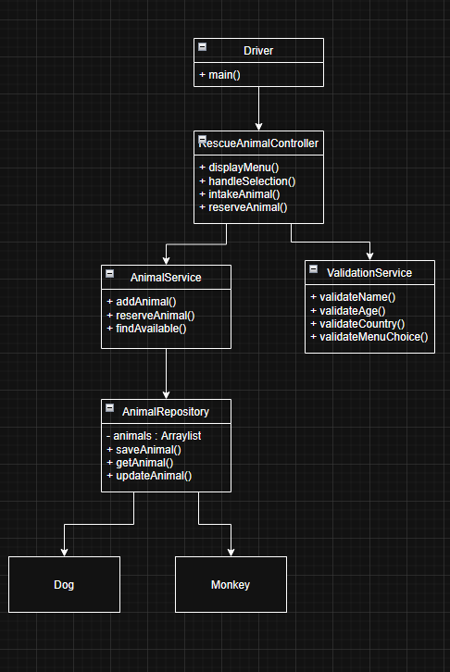

For this category of enhancement, consider improving a piece of software, transferring a project into a different language, reverse engineering a piece of software for a different operating system, or expanding a project’s complexity. These are just recommendations. Consider being creative and proposing an alternative enhancement to your instructor.

Think about what additions to include to complete the enhancement criteria in this category. Since one example option is to port to a new language, that is the kind of scale that is expected. This does not mean you need to port to a new language but instead have an equivalent scale of enhancement. Underlying expectations of any enhancement include fixing errors, debugging, and cleaning up comments, but these are not enhancements themselves.

    - Explain how the planned enhancement will demonstrate specific skills and align with course outcomes.

      - Identify and describe the specific skills you will demonstrate that align with the course outcome.

This enhancement will demonstrate object oriented software principles by redesigning the rescue animal system into a layered architecture with separate controller, service, and validation. It will demonstrate skills in class decomposition, abstraction, encapsulation, modular design, input validation, and exception handling.

      - Select one or more of the course outcomes below that your enhancement will align with.

Outcome #4: The layered design, validation services, and modular components demonstrate professional software engineering techniques.
Outcome #5: Input validation provides a layer of security against potential exploits that the current program currently lacks.

Course Outcomes:

- Employ strategies for building collaborative environments that enable diverse audiences to support organizational decision-making in the field of computer science.
- Design, develop, and deliver professional-quality oral, written, and visual communications that are coherent, technically sound, and appropriately adapted to specific audiences and contexts.
- Design and evaluate computing solutions that solve a given problem using algorithmic principles and computer science practices and standards appropriate to its solution while managing the trade-offs involved in design choices.
- Demonstrate an ability to use well-founded and innovative techniques, skills, and tools in computing practices for the purpose of implementing computer solutions that deliver value and accomplish industry-specific goals.
- Develop a security mindset that anticipates adversarial exploits in software architecture and designs to expose potential vulnerabilities, mitigate design flaws, and ensure privacy and enhanced security of data and resources.

  - Category Two: Algorithms and Data Structures

- Select an artifact that is aligned with the algorithms and data structures category and explain its origin. Submit a file containing the code for the artifact you choose with your enhancement plan. You may choose work from the courses listed under Category One.

IT 145 Project II

- Describe a practical, well-illustrated plan for enhancement in alignment with the category, including a pseudocode or flowchart that illustrates the planned enhancement.

IT 145 Project II is a program that runs a menu for a rescue animal service. This is the same artifact as categories one. For this enhancement, I would like to add ways for the the user to search for specific animals by attributes, such as names, species, and reservation status. To improve the efficiency of these operations, I would implement a HashMap for fast lookup by unique identifier or name, and use sorting algorithms to organize animal records before performing binary searches when appropriate. These enhancements will reduce search time compared to the linear search approach I have currently employed.

Pseudocode:

START PROGRAM
Load animals
Create HashMap

FOR each animal
Add animal to hashmap

Display Search menu
Read user input

IF search by ID or Name
Retrieve animal using hashmap
Display result
ELSE IF search by training status
Filter animal list
Display result
ELSE IF search by sorted attribute
Sort animal list
Perform binary search
Display result
ELSE
Display “Invalid selection”

For this category of enhancement, consider improving the efficiency of a project or expanding the complexity of the use of data structures and algorithms for your artifact. These are just recommendations. Consider being creative and proposing an alternative enhancement to your instructor. Note: You only need to choose one type of enhancement per category.

Think about what additions to include to complete the enhancement criteria in this category. Since one example option is to port to a new language, that is the kind of scale that is expected. Perhaps you might increase the efficiency and time complexity of an algorithm in an application and detail the logic of the increased time complexity. Remember, you do not need to port to a new language but instead have an equivalent scale of enhancement. Underlying expectations of any enhancement include fixing errors, debugging, and cleaning up comments, but these are not enhancements themselves.

- Explain how the planned enhancement will demonstrate specific skills and align with course outcomes.

  - Identify and describe the specific skills you will demonstrate to align with the course outcome.

This enhancement will demonstrate the ability to analyze and improve algorithm efficiency by selecting appropriate data structures for specific operations. It will demonstrate proficiency in implementing HashMap collections for contstant time lookups, sorting algorithms to organize data, and binary search techniques to improve search performance over linear searches.

  - Select one or more of the course outcomes listed under Category One that your enhancement will align with.

Outcome #3: This enhancement focuses on selecting efficient data structures and algorithms to improve application performance.
Outcome #4: Implementing HashMap collections, sorting algorithms, and binary searches demonstrates the use of established computer science techniques to improve the application’s performance and usability.

  - Category Three: Databases

    - Select an artifact that is aligned with the databases category and explain its origin. Submit a file containing the code for the artifact you choose with your enhancement plan. You may choose work from the courses listed under Category One.

IT 145 Project II

    - Describe a practical, well-illustrated plan for enhancement in alignment with the category, including a pseudocode or flowchart that illustrates the planned enhancement.

IT 145 Project II is a program that runs a menu for a rescue animal service. This is the same artifact as categories one and two. For this category, I would like to replace the hardcoded test animals with a proper database, aswell as implementing CRUD functionalities for it. This would be added to a new database layer allowing the program to automatically retrieve, edit, or remove existing animals records and the ability to save new ones.

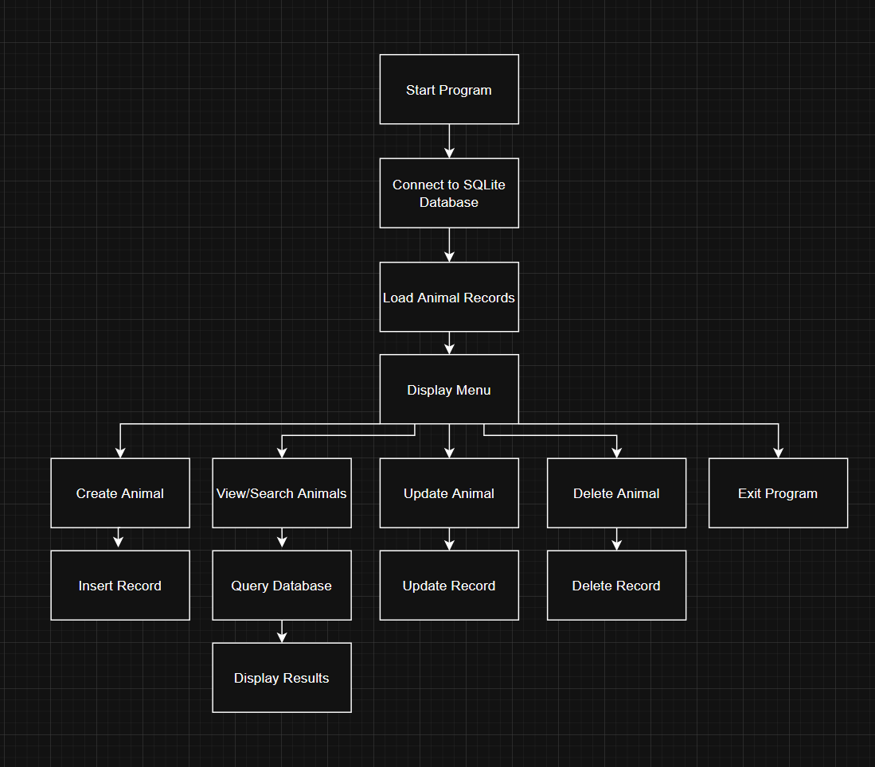

For this category of enhancement, consider adding more advanced concepts of MySQL, incorporating data mining, creating a MongoDB interface with HTML/JavaScript, or building a full stack with a different programming language for your artifact. These are just recommendations; consider being creative and proposing an alternative enhancement to your instructor. Note: You only need to choose one type of enhancement per category.

Think about what additions to include to complete the enhancement criteria in this category. Since one example option is to port to a new language, that is the kind of scale that is expected. Perhaps you might increase the efficiency and time complexity of an algorithm in an application and detail the logic of the increased time complexity. Remember, you do not need to port to a new language but instead have an equivalent scale of enhancement. Underlying expectations of any enhancement include fixing errors, debugging, and cleaning up comments, but these are not enhancements themselves.
    - Explain how the planned enhancement will demonstrate specific skills and align with course outcomes.

      - Identify and describe the specific skills you will demonstrate that align with the course outcome.

This enchancement will demonstrate database design and integration skills by replacing tempory in memory storage with a persistent database.

      - Select one or more of the course outcomes listed under Category One that your enhancement will align with.

Outcome #3: This enhancement improves the application’s design by implementing a scalable database solution that provides persistent data storage and more efficient data management than the current in memory collections used.

- ePortfolio Overall Skill Set

  - Accurately describe the skill set to be illustrated by the ePortfolio overall.
    - Skills and outcomes planned to be illustrated in the code review

The code review will mainly deomonstate course outcomes #3 and #4 by highlighting my understanding of object oriented programming, software architecture, algorithm efficiency, and database integration. I will also touch on Outcome #5 through the use of input validation and how it is important for secure software design.

    - Skills and outcomes planned to be illustrated in the narratives

The enhancement narratives will demonstrate my ability to to apply computer science principles to improve an existing software application. Each narrative will focus on a different area of computing: software engineering through architectural redesign and modularization, algorithms and data structures through efficient searching and data organization, and databases through persistent data storage and CRUD operations. The narratives will explain the design decisions, implementation process, and trade offs associated with each enhancement.

    - Skills and outcomes planned to be illustrated in the professional self-assessment

The professional self-assessment will reflect on my growth throughout my journey through two computer science programs, one here at SNHU, and another at my previous institution, Northern Essex Community College. It will demonstrate my ability to integrate knowledge from multiple courses into a cohesive software project, and hightlight my development in software engineering, object oriented programming, database design, and problem solving. I will also discuss how completing these enhancements has strengthened my ability to design, implement, and evaluate computing solutions while preparing me for professional software development. Overall it will demonstrate my readiness to apply industry standards and best practices and continue developing my technical skills.

